

Coffee Shop Sales

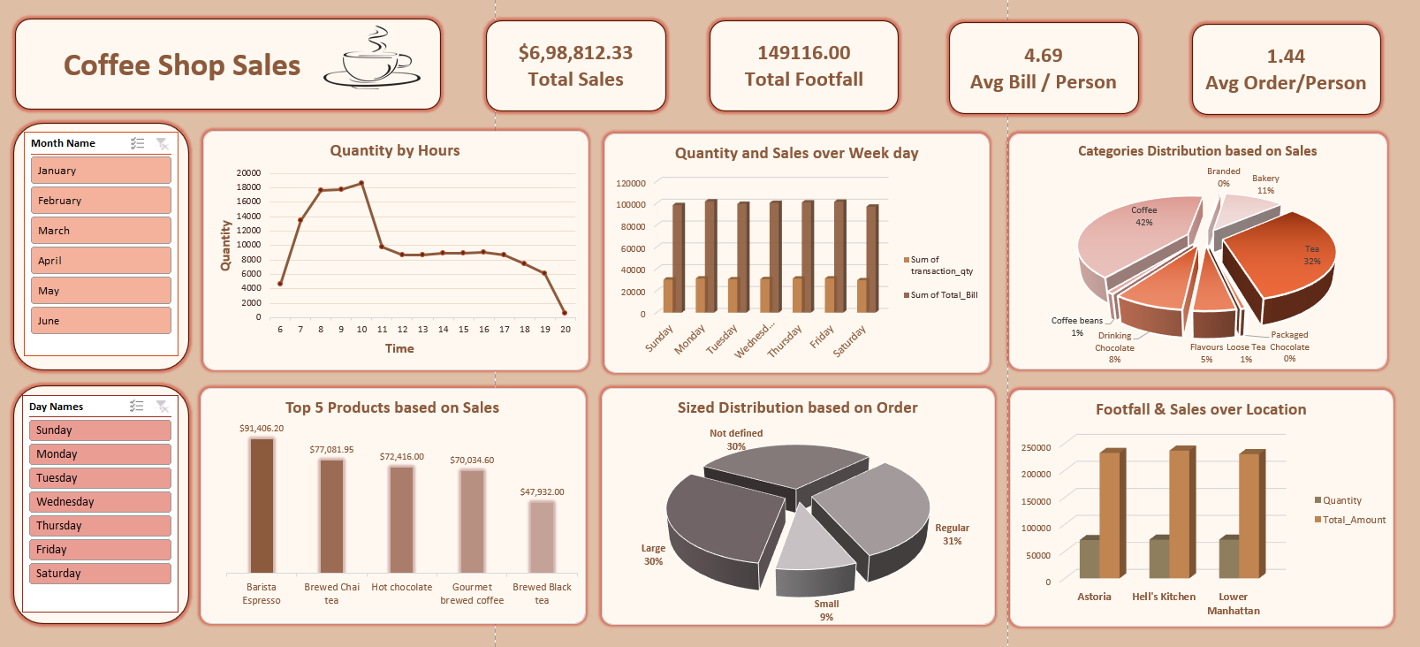

- Total money earned : $6,98,812
- Total number of customers who visited: 2,14,470
- On average each customer spent: $4.69 per visit
- On average each customer ordered: 1.44 items per visit

Sales by Time of Day
- Best time: 8 AM to 10 AM - this is when most sales happen
- Worst time: After 6 PM - sales drop very sharply
- Peak quantity during morning rush goes above 18,000 units

The morning is the most important time for the business. All staff and stock should be ready before 8 AM. Evening time is very slow .

Sales by Day of Week
- Monday and Friday have the highest sales
- Saturday and Sunday has the lowest sales

The coffee shop is more of a weekday business. People buy coffee before or after work on weekdays.

Monthly Revenue Trend
- January: $81,677
- February: $76,145 - only month with a drop
- March: $98,834
- April: $1,18,941
- May: $1,56,727
- June: $1,66,485

Revenue more than doubled from January to June. This is very good growth. February was the only bad month with a small drop. From March onwards every month showed strong growth.

Sale of 3 Locations
The coffee shop has 3 locations. Here is how each one performed:
- Hell's Kitchen: 71,737 units sold, Revenue = $2,36,511
- Lower Manhattan: 71,742 units sold, Revenue = $2,30,057
- Astoria: 70,991 units sold, Revenue = $2,32,243

All three locations are performing at almost the same level which is very good. The difference between the best and worst location is only $6,454. However Lower Manhattan sells the most units but earns the least money. This means customers there are buying cheaper items. Staff at Lower Manhattan should try to suggest higher priced items to customers.

Top 5 Products by Revenue
- 1st - Barista Espresso: $91,406
- 2nd - Brewed Chai Tea: $77,081
- 3rd - Hot Chocolate: $72,416
- 4th - Gourmet Brewed Coffee: $70,034
- 5th - Brewed Black Tea: $47,932

Barista Espresso is the number one product by a big margin.

Sales by Category
- Coffee: 42% of total sales - biggest category
- Tea: 32% of total sales - second biggest
- Bakery: 11% of total sales
- Drinking Chocolate: 8%
- Flavours: 5%
- Others (Branded, Packaged ): 2%

Order Size Distribution
- Regular size: 31% of orders
- Large size: 30% of orders
- Not Defined: 30% of orders - no size recorded
- Small size: only 9% of orders

